Regular lessons
Lessons will be held weekly and sold in 5 lesson blocks of $355 (students are to provide their own clay).
One lesson is 3 hour long ($71 per lesson = $23.70 per hour)
Lessons have been made in 5 lesson blocks so students don’t feel pressure to commit to too much time and cost. If you complete one 5 lesson block and need a break then jumping back in at an appropriate time later in the year is fine for me. This will however depend on class numbers and current student projects and the re-entering student’s project.
The classes are run in my personal studio and adjacent space. They are limited to 3 – 5 students per class. The classes are intentionally kept small to prioritise the student’s learning and give them more one on one time with me. This gives students the opportunity to discuss and digest technique and method in their own time. As the lessons are more focused on learning process than achieving outcome.
How you move through the projects and how much effort you would like to commit is entirely up to the individual. This is to be clarified in discussion before commencement. If at anytime we both agree you have finished a project then you can move directly to the next.
Students will begin working from casts, starting with the 4 David’s features. The casts are provided by the studio and available for students use through out the lessons. The students are able to take one cast home to continue working in between lessons. This is only if it doesn’t interfere with another student’s work. If a cast is broken by a student whilst in their care at home or at the studio then the student is required to cast another one for me as soon as possible .
The four David’s Features by Michelangelo
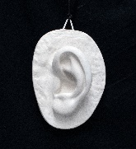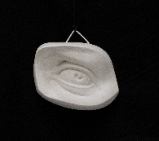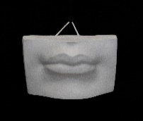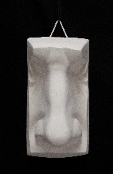
In the first 5 lessons block I expect you to attempt and near completion two casts of the David’s features. That’s one cast every two weeks (this will require some work from home). On the 5th lesson the student can either push one of their casts further beyond the initial completion or make a waste plaster mould of one of their casts.
To put this in perspective at the Florence Academy of Art students would typically spend 15 hours of lesson time on one David’s feature.
To simplify this process the students will work from multiples of the same cast i.e. the lips, at the same time. Each feature will start with an introductory talk that covers some key features of that cast which is synonymous to that facial structure i.e, basic anatomy and landmarks. This will help to prepare the students for portraiture should they choose to continue with the lesson plan. I will also cover the basic method of sculpting and give demonstrations to the group when needed. Furthermore, students can benefit from listening to other student’s critiques as they may be experiencing similar problems in their own process.
The second 5 lesson block Students will finish the remaining two features of the David’s casts. However, depending on your class mates this can be negotiated. If you are attending these lessons to improve your sculpting in the model room. Then I would then strongly suggest using one lesson for the exercise of sculpting a pear or capsicum (trust me it’s a genius exercise)

The third 5 lesson block we will sculpt a cast of a skull. This is important study in relationship to portraiture. In the 5-week lesson block we will discuss the anatomy of the skull and improve your understanding of the sculpting method. This will help in our next project of sculpting the portrait. I would expect this to take 3 - 4 lessons. If we finish earlier, we can start the next project. I am currently sourcing a cast suitable to work on for portraiture. So, when the students finish the skull or have learnt the lessons associated with this exercise they can then move to the portrait cast.
Then for the fourth 5 lesson block the students will attempt a portrait. Students are responsible for the cost of the model. This cost can be split between all attending students. Students can also find someone they know to sit for them. Students also have the option of working from a plaster cast if needed. We will work together to find the most affordable option for everyone. Students are not advised to work from photographs for this first portrait. This expected to take at least 5 weeks. If time goes over students can work on a week by week lesson program if wanted.
After this student can pick their project, anything is up for discussion!!
Cancellation of Lessons
Regarding students cancelling or missing lessons.
When working from casts, if a student can not attend a lesson, they will be given an opportunity to make up this lesson at the end of the 5 weeks. This lesson will directly be in following week and in the same time slot, unless agreed otherwise. There will be no opportunity to make up any other missed lessons. No refunds can be given. Students can however take casts home within that 5 week lesson block to work on them and catch up in their spare time.
When working from life, students that miss lessons will not be given an opportunity to make up that lesson. There can be no refund given. They are still expected to cover the cost of their part of the model. As all lesson costs have been calculated on a fixed timeframe and number of student attendance. There may be an opportunity for an extra critique without the model. This can be discussed at the time as ultimately, I want to provide a quality education.

