Georgina’s Cast List – mills.georgina@gmail.com
Please note all prices are in AUD $ and do not include shipping/ packing and insurance, a quote will be needed so please supply me with your postcode and email address. I am also happy for studio pick up if you are located in or can get to Adelaide.
 | Name | Measurements  H x W x D cm | price | Weight
 | The David’s Features by Michelangelo
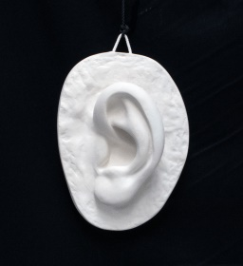 | Ear, 1 | 21x 16 x 8 cm | $65.00AUD | 1.5kg
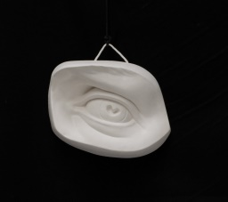 | Eye, 1 | 18 x 16 x 10cm | $65.00 AUD | 1.5kg
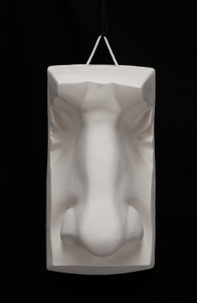 | Nose | 27 x 16 x 13 cm | $65.00 AUD | 1.6kg
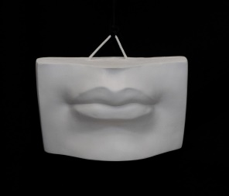 | Lips | 13 x 19 x 8cm | $65.00 AUD | 1.5kg
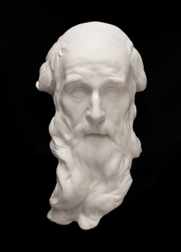 | Saint Andrew | 44 x 25 x 16 cm | $92.00 AUD
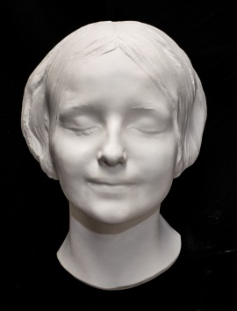 | L’Inconnue de la Seine (lady of Seine, Death Mask) | 29 x 20 x 15 cm | $92.00 AUD | 2kg
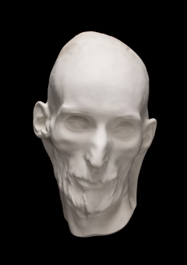 | Gericault (Death Mask)  Theodore Gericault a 19th century French painter | 27 x 19 x 17 cm | $92.00 | 2 kg
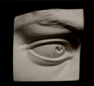 | David’s eye 2, | 16 x 17 x 11cm | $65 | 1.4 kg
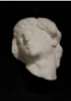 | Michelangelo’s dying slave, | 35 x 28 x 20 cm | $105 | 3 kg
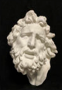 | Laocoon Mask | 24 c 40 x 19 cm | $125 | Approx3.4 kg
Coming soon
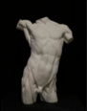
Lanteri Torso, 39 x 14 x 27 cm - $275- 5.5 kg

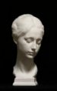
Portrait of a girl, 21 x 23 x 43 cm - $ 260 - 4.7kg

